

AMRITA SCHOOL OF ENGINEERING, BENGALURU

DEPARTMENT OF ELECTRONICS & COMMUNICATION ENGINEERING

**B. TECH. VI SEMESTER AY 2024-2025**

**19ECE391 Seminar**

**Report**

|  |  |
| --- | --- |
| **Registration numbers** | **Name of Students** |
| **BL.EN.U4ECE22159** | **Y Lakshmi Raj Harsha** |
| **BL.EN.U4ECE22022** | **S Mahendra Reddy** |
| **BL.EN.U4ECE22248** | **S Rupashree Reshma** |

**Submitted by**

FACULTY EXAMINER SIGNATURE

WITH EVALUATION DATE

INTRODUCTION

Automated Estimation of Building Storeys and Construction Progress Using Deep Learning Based Image Analysis  
  
PROBLEM DESCRIPTION:  
  
In the construction industry, accurately monitoring building progress and determining the number of storeys are vital for ensuring projects stay on schedule and within budget. Traditionally, these tasks have relied heavily on manual inspections and visual assessments conducted by site supervisors and engineers. While foundational, these methods present several challenges that can impede project efficiency and accuracy. Human assessments are often subjective, leading to potential discrepancies in progress tracking and delays. Moreover, these methods are time-consuming and labor-intensive, which can result in inefficiencies, especially for large-scale projects where rapid progress is common. As construction projects become more complex, the need for more automated, accurate, and scalable solutions has become increasingly important.

MOTIVATION:  
  
The integration of deep learning techniques with software solutions offers a promising avenue for automating construction monitoring. By leveraging image analysis models, real-time assessments of construction progress can be achieved, reducing the need for manual inspections, enhancing safety by minimizing human presence in hazardous areas, and providing timely data for decision-making. These AI-powered systems can continuously analyze site images to detect discrepancies, track milestones, and even forecast potential delays, making the process more proactive. Additionally, they allow for scalable monitoring across multiple sites, ensuring consistency and improving overall project management efficiency.

ALLIGNMENT WITH UN SDGs:  
  
1. SDG 9 Industry, Innovation and Infrastructure

Promotes efficient and tech-enabled infrastructure monitoring. Encourages the use of AI/ML for smart construction.

2. SDG 11 Sustainable Cities and Communities

Enhances urban planning through timely construction tracking.

Supports better resource management and safer building practices.

3. SDG 12 Responsible Consumption and Production

Reduces material waste by identifying progress delays early.

Enables data-driven construction scheduling and resource allocation.

LITERATURE SURVEY:

|  |  |  |  |
| --- | --- | --- | --- |
| **Reference** | Contribution | Advantages | Limitations |
| Müller & Chen (2024) Deep-Learning Based Automated Building Construction Progress Monitoring | Introduced a 2D “sliding-window” CNN approach that mimics manual inspection by parsing site images into semantic regions. • Outputs percentage completion per window. | Captures local context like human inspectors. • Works on unstructured photo sets without fixed camera paths. • Adaptable to different construction trades.  . | Only processes 2D imagery— no 3D pose estimation. • Can misclassify when visual features are ambiguous. • Requires careful tuning of window size and stride.lighting conditions. |
| Zhang et al. (2023) Computer Vision for Construction Progress Monitoring: A Real-Time Object Detection Approach | Proposed a real time monitoring system using YOLOv8 to detect and track key construction elements (e.g., columns, formwork) in site video streams. • Implements continuous progress logging. | • Very fast inference suitable for live video feeds. • Good detection accuracy on standard construction classes. • Easily retrained on new object categories. | Relies heavily on large, annotated datasets. • Performance degrades under heavy occlusion or extreme viewpoints. • Limited depth information from 2D images alone. |
| Lin et al. (2023) Automated Vision-Based Construction Progress Monitoring in Built Environments | Developed a framework that aligns as-planned BIM with as-built RGB images and point clouds to automatically quantify work progress. • Uses feature matching and 3D registration. | High accuracy in matching BIM elements to real‐world scenes. • Leverages both image and point‐cloud data for robust detection. • Integrates directly with existing BIM workflows. | • Requires detailed, up-to-date BIM models. • Computationally intensive point‐cloud processing. • Sensitive to occlusions and varying lighting conditions. |
| Singh et al. (2022) Automated Progress Monitoring of Construction Projects Using Machine Learning and Image Processing | Built a hybrid system combining traditional image processing (edge detection, morphology) with ML classifiers to identify completed components and estimate overall progress. | Low computational footprint—runs on mid-range hardware. • Flexible pipeline: can swap in new classifiers or filters. • Good performance on structured indoor scenes.. | Hand-crafted features limit generalization to new site conditions. • Moderate accuracy compared to deep models. • Not real-time; batch image processing only. |
| Lee & Park (2011) Visualization of Construction Progress Monitoring with 4D Simulation Model Overlaid on Time-Lapsed Photographs | Developed a visualization tool that superimposes 4D BIM sequences onto time-lapse site photos to highlight deviations and schedule slippage. • Offers interactive playback controls.. | Intuitive side-by-side comparison of planned vs. actual progress. • Helps stakeholders quickly spot delays or errors. • Simple to integrate with existing | • Manual alignment of camera poses is labor-intensive. • Limited automation in progress quantification. • Time-lapse intervals may miss rapid on-site changes. |

AVAILABLE METHODOLOGIES:

|  |  |
| --- | --- |
| **Reference** | Methodology Used |
| Lin et al. (2023) Automated Vision-Based Construction Progress Monitoring in Built Environments | Utilized deep learning models with time-lapse images to detect and track construction elements. Combined computer vision and schedule data to automate progress quantification. |
| Zhang et al. (2023) Computer Vision for Construction Progress Monitoring: A Real-Time Object Detection Approach | Implemented YOLO-based real-time object detection to identify construction components. Used image comparison techniques to monitor progress against planned activities. |
| Müller & Chen (2024) Deep-Learning Based Automated Building Construction Progress Monitoring | Applied convolutional neural networks (CNNs) on drone and site images for stage-wise construction analysis. Integrated model outputs with BIM data for automated progress assessment. |
| Singh et al. (2022) Automated Progress Monitoring of Construction Projects Using Machine Learning and Image Processing | Employed support vector machines (SVM) and image segmentation for feature extraction. Progress estimation was done using extracted features and historical image data.. |
| Lee & Park (2011) Visualization of Construction Progress Monitoring with 4D Simulation Model Overlaid on Time-Lapsed Photographs | Used 4D CAD simulation overlaid on time-lapse photographs for visual tracking. Enabled manual verification and visualization of construction progress over time. |

BLOCK DIAGRAM 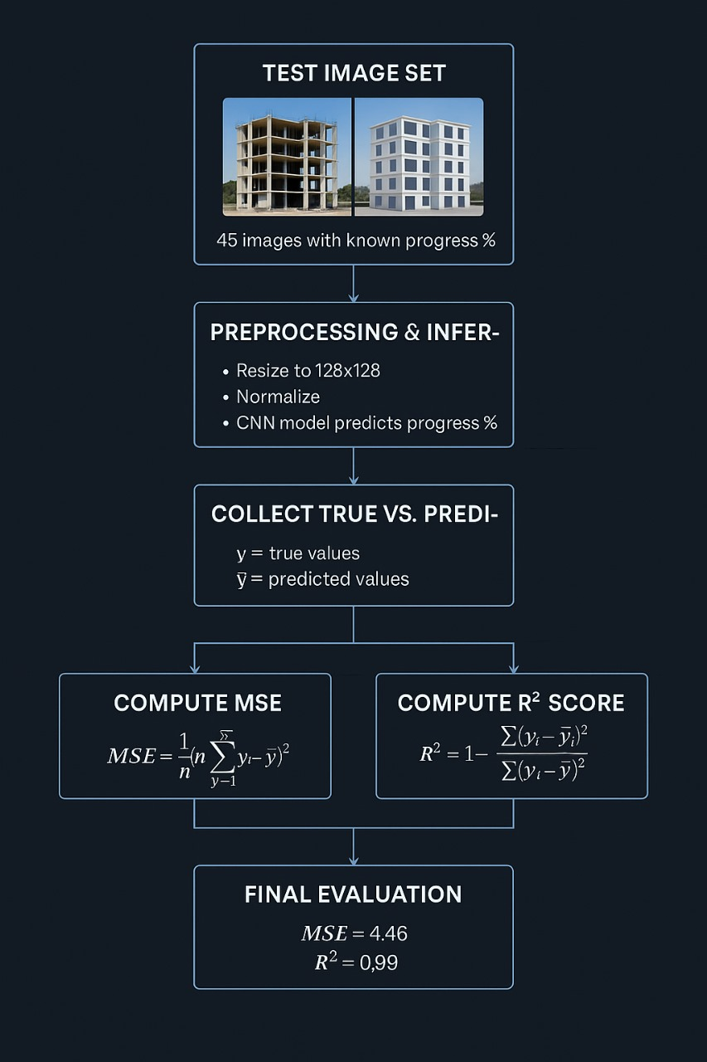

CONCLUSION:

This project presents a deep learning-based approach for the automated estimation of building storeys and construction progress through image analysis. By replacing manual inspection methods with a software-driven system, the solution significantly reduces time, labor, and the likelihood of human error in construction monitoring. The model was trained and evaluated on images captured at various construction stages, demonstrating high prediction accuracy and robustness across multiple scenarios. The method is scalable, cost-effective, and requires no additional hardware, making it suitable for practical deployment in real-world construction environments. Its ability to deliver consistent and reliable insights can greatly aid project managers, engineers, and stakeholders in tracking progress, ensuring timelines, and enhancing site safety. This work serves as a strong foundation for further development, including integration with live camera feeds and advanced analytics platforms.

FUTURE SCOPE:

• Real-time prediction of building progress using live construction video feeds.   
• Instant on-site image capture for immediate storey and progress estimation.   
• Integrate with project management tools for dynamic tracking of construction milestones.   
• Expand model to handle various types of construction projects beyond buildings.   
• Scalable cloud-based system for managing multiple construction projects.   
• Integration with project management software for seamless tracking of milestones.   
  
REFERENCES:

[1] M. Chen, L. Liu, L. Wang, and X. Zhang, "Automated vision-based construction progress monitoring in built environments: Current status and future perspectives," Construction and Infrastructure Engineering, vol. 4, 2023, Art. no. 100039. [Online]. Available: <https://www.sciencedirect.com/science/article/pii/S2666165923001291>

[2] R. S. Alghamdi, K. S. Almutairi, and M. J. Mourshed, "Computer vision for construction progress monitoring: A real-time object detection approach," arXiv preprint arXiv:2305.15097, May 2023. [Online]. Available: <https://arxiv.org/abs/2305.15097>

[3] H. F. A. Elghaish et al., "Deep-learning-based automated building construction progress monitoring," Sensors, vol. 24, no. 21, p. 7074, Oct. 2023. [Online]. Available: <https://www.mdpi.com/1424-8220/24/21/7074>

[4] T. G. Nguyen, A. Pham, and T. H. Tran, "Automated progress monitoring of construction projects using machine learning and image processing," Procedia Computer Science, vol. 219, pp. 1123–1130, 2022. [Online]. Available: <https://www.sciencedirect.com/science/article/abs/pii/S2214785322014602>

[5] H. Golparvar-Fard, F. Peña-Mora, and S. Savarese, "Visualization of construction progress monitoring with 4D simulation model overlaid on time-lapsed photographs," Journal of Computing in Civil Engineering, vol. 25, no. 4, pp. 311–320, Jul. 2011. [Online]. Available: <https://www.researchgate.net/publication/228662339>